The Meadow Lake First Nations Governance Program
Since 1998 the Meadow Lake Tribal Council has supported each Meadow Lake First Nation in the development of a community-specific Constitution. The core Meadow Lake Tribal Council team has been working with each First Nation on the development of Constitutions, Self-government budgets (cost-substantiation packages) and communications.

At the heart of this program is the negotiation table involving representatives from each Meadow Lake First Nation, the province of Saskatchewan and the federal government. Over the last 18 years the Chiefs and Councils of the Meadow Lake First Nations have been driven to develop and implement their Self-government agreements. There have been significant steps taken towards reaching the Constitution stage and now many of the Meadow Lake First Nations are well into the drafting process. This process has seen an ever-increasing potential for First Nations people to regain full control of their lands, their resources and their future.

Currently there are Governance Agreements going on with Canada and a Tripartite Governance Agreement going on with the province. Upon internal review and further negotiation these agreements will be the framework by which the Meadow Lake First Nations govern themselves in relation to Saskatchewan and the rest of Canada.

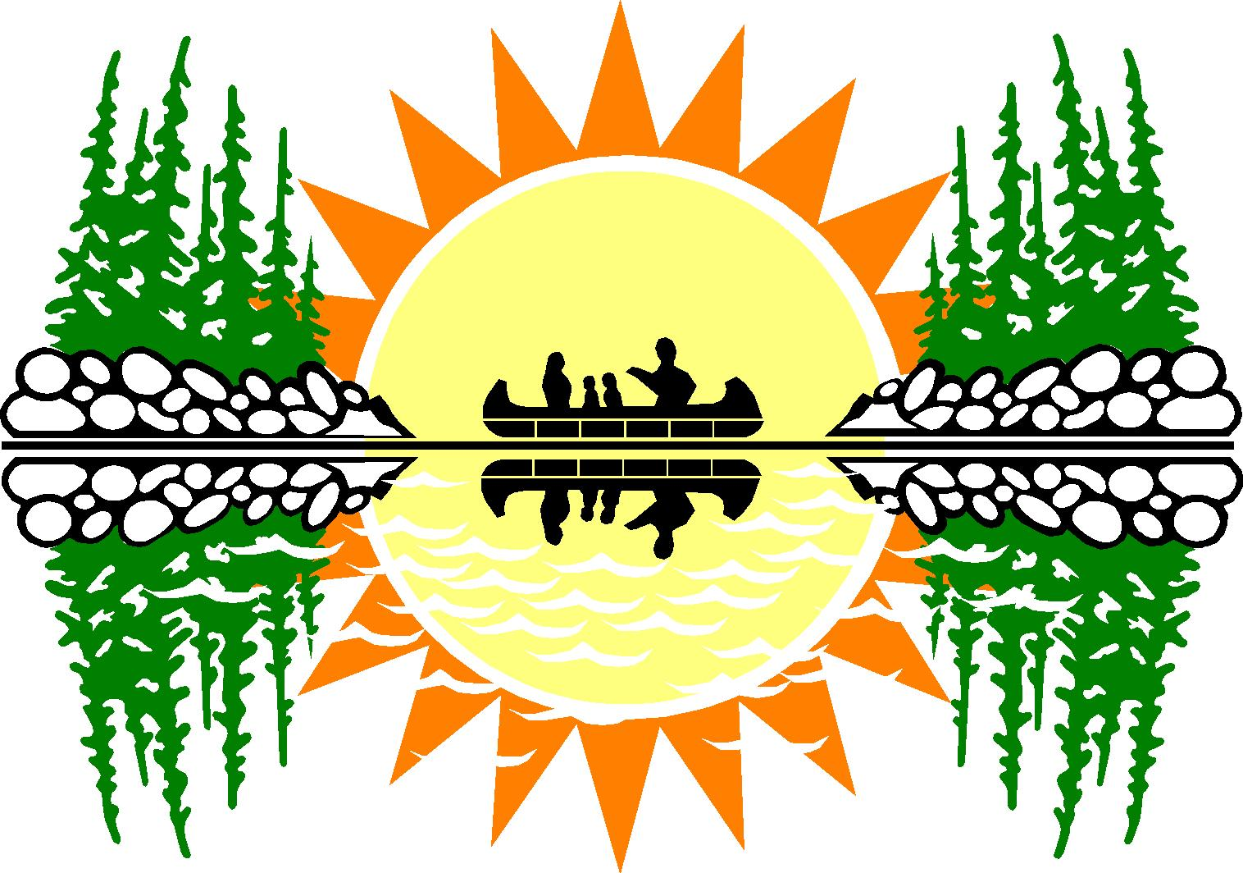
The Meadow Lake First Nations and Meadow Lake Tribal Council remain committed to making Self-government a common reality. With continuing support and input from community members, leaders and Elders this initiative will maintain its growing record of success.
Meadow Lake First Nations
Governance
Our Way, Our Vision, Our Future

The New Governance Logo

Meadow Lake First Nations
Governance
Our Way, Our Vision, Our Future

Introducing the new Meadow Lake First Nations Governance logo. From time immemorial, First Nations have utilized the age-old skill of mnemonics (pronounced ni-'män-iks). This logo brings a story from our memories. It is full of meaning starting with the sunrise. The sunrise brings a new day. This new day provides a chance to improve on the day before. Along with the new day come new challenges. These challenges can be over come by our people as a whole. There are nine rays each representing our nine bands. In the middle is a picture of a family in their birch bark canoe. Both the Dene and Cree shared resources, technologies, sciences, medicines, and governance to maintain peace, friendship and partnerships. The waters, trees and land represent the wealth of our resources and that we must continue to adapt, prosper and flourish on our lands.

For More Information Contact
Website: www.mltc.net
Phone: 306-236-5654 Fax: 306-236-6301
Date: March 2006



Message From Tribal Chief Helen Ben
Tānsi, it is great to be able to pass on a message from the Office of the Tribal Chief. I think that open communication is one of the best means of keeping our Tribal Members informed about the direction that we are going as a Tribal Council.

There have been years of work dedicated to the Self-government file. The staff within the Self-government department have been busy negotiating and preparing strategy as well as documents required to assist in the road to implementing Self-government.

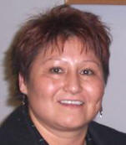
I am very pleased to hear that more information will be presented in different formats to the members of the eight First Nations. I believe that we are at a crucial time of negotiations and that the work done thus far will be up for
Tribal Chief Helen Ben ratification.

In order to make an informed decision, one must have full or as complete an understanding as possible. Self-government is an important topic and must be considered with full knowledge of the implications.
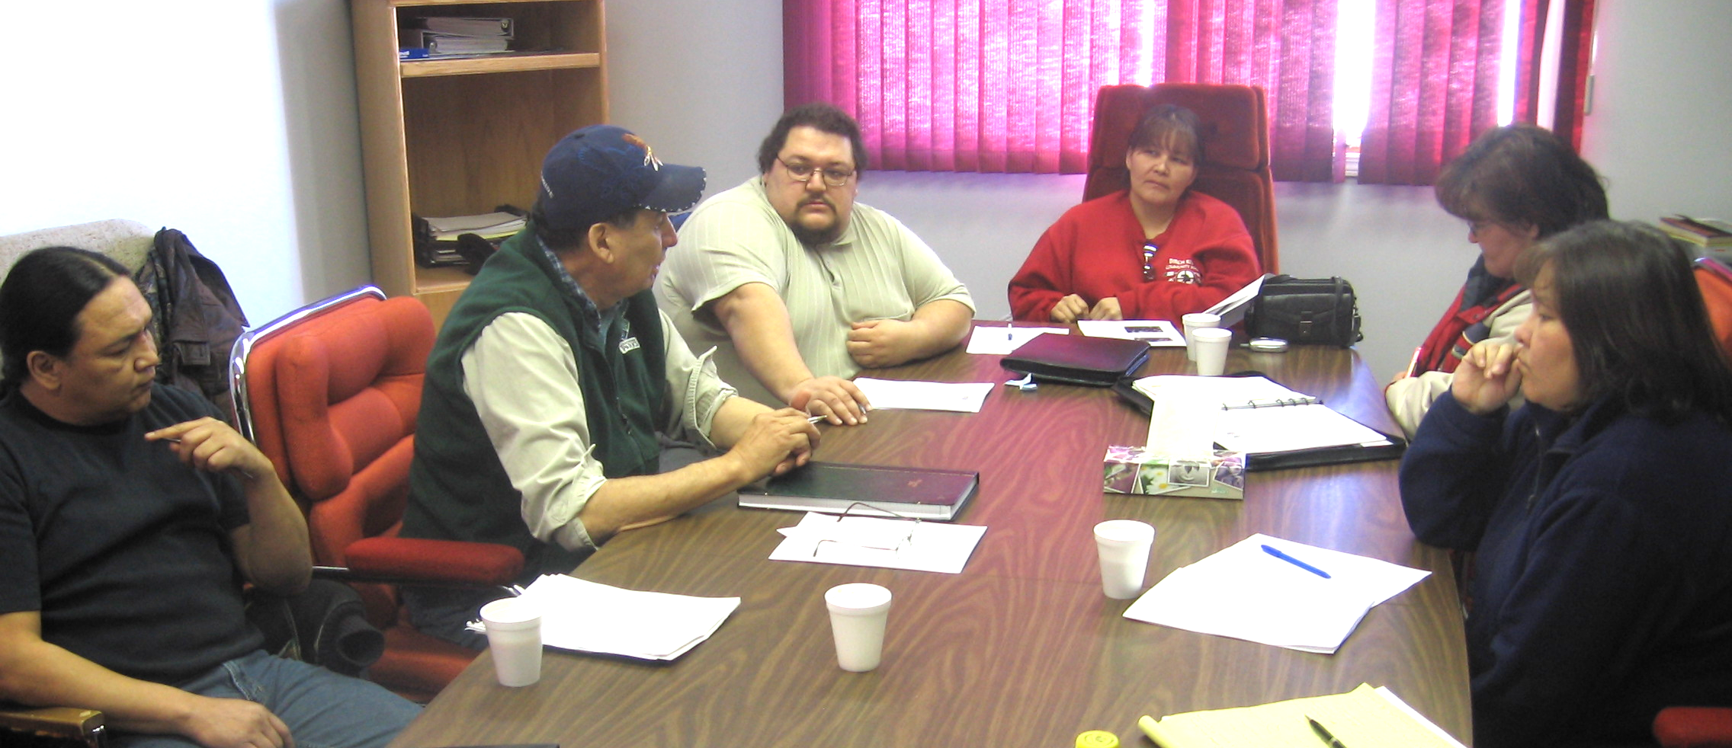
I urge all members to read and debate the issue as much as possible. The office of Self-government will provide the information in different formats as to better enable full understanding.
Mahsi cho and thank you.
Community Self-government Coordinators Meeting
Following opening remarks, both Isidore Campbell and Armond Fiddler presented insightful views of Self-government and urged each of the Self-government Coordinators to continue their work and their efforts for the good of the people and our future. Mr. Campbell explained the next steps of community consultations in the “Open House” style.
The “Open House” model is adopted from the Blood Tribe, which has been very effective.
Like the Bloods, the Meadow Lake Tribal Council governance team will go to each of the communities and assist the coordinators, researcher and two Elders to present different sections of the Governance Agreement.
The Governance Agreement is then broken down into sections for better understanding. These information sessions will be getting broken down further into displays and informational pamphlets for people to take home and discuss. Also on the horizon is a Governance website that will feature all the information the public may want to access.
Each of the coordinators provided updates on their community initiatives. Some of the common responses were that having the Main Table Negotiators at the community consultations was a positive and members were glad to see them. Further invitations were given by most of the communities and more were scheduled throughout March.
There were a lot of ideas on consulting the communities. Some of these ideas included holding informational sessions over pancake breakfasts served by the leadership, having phone-in sessions on local radio/tv stations and off-reserve meetings for people that were a part of the nine bands. There is a definite need for off-reserve consultations and more strategies will be discussed in the near future.
Each of our eight First Nations has a Self-government Coordinator that creates awareness of the negotiations and governance issues. Some of their responsibilities are to re-align the Constitution Development Committees (CDC) into Governance Committees (GC). The GC’s will then continue to work and develop their community constitution. Some of the CDC’s have held community information sessions and consultations on topics such as preamble, lands, government structures, delegation of powers, choosing leaders, passing laws, accountability, citizenship and other general items.
The first meeting of 2006 started with introductions and updates from each of the eight Self-government Coordinators. The eight coordinators present gave positive remarks about their communities. Kevin Lewis was introduced to the coordinators as the new Communications and Consultations Coordinator.
On the agenda, surveys were presented to the coordinators to have the communities take part in. The main objective of the survey was to consult the communities on the future direction of Meadow Lake Tribal Council. This gives the grassroots involvement in the evolution of their Tribal Council. The survey will be presented at the March General Assembly taking place in Saskatoon.

Coordinators updating on community progress.

Back to Governance Website

www.mlfn.ca

